Run object detection in Matlab

The required camera drivers are necessary, to be able to connect the camera of the robot to your laptop. This is achieved by downloading and running

**Galaxy_Windows_EN_32bits-64bits_1.12.2106.9032.exe**

from camera driver folder at the canvas page.

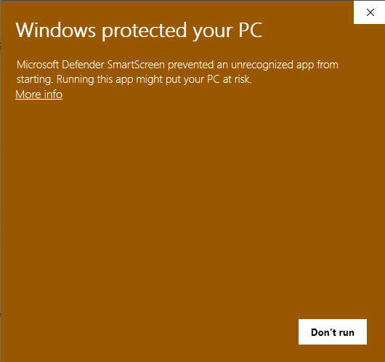

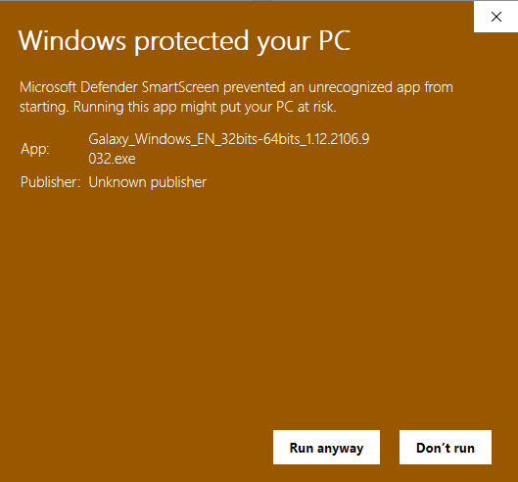

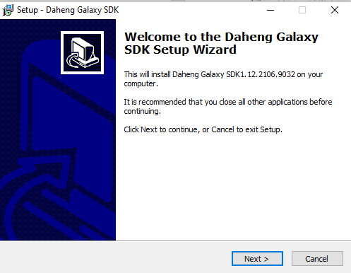

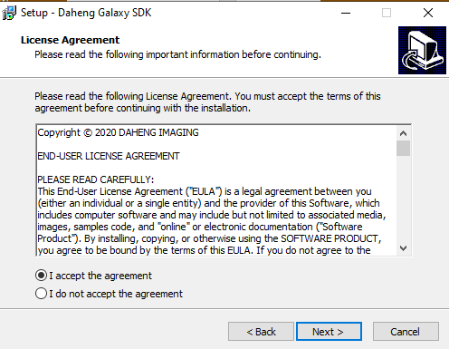

Choose right folder

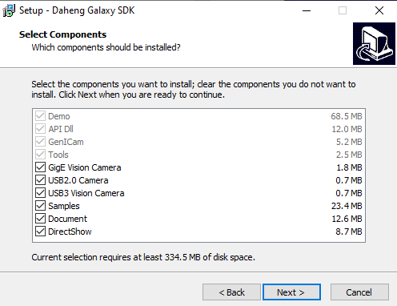

Check all boxes

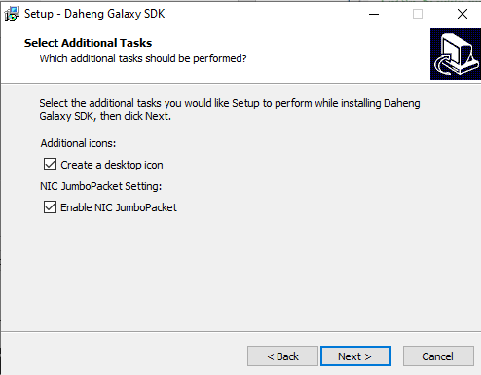

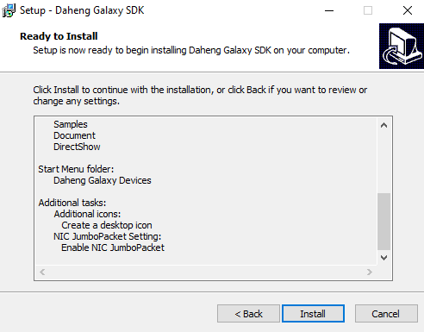 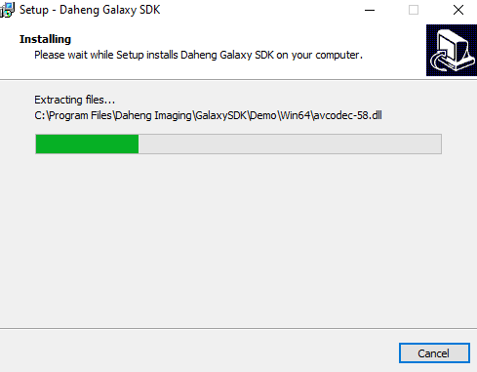

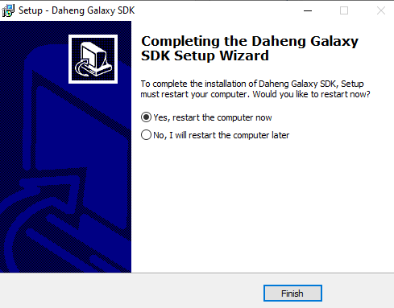

**Required toolboxen**

To run object detection in Simulink, the following toolboxes are required.

**Image Acquisition Toolbox**

**Image Acquisition Toolbox Support Package for OS Generic Video Interface**

**Computer Vision Toolbox**

**Image Processing Toolbox**

After restarting your pc, the camera can be plugged in your usb port (power usb) and connected in Matlab by running **camera.m** script.

